
Department of Computer Science &
Information Technology

University of Sargodha

Final Project
Version 1.0

Revision History
This section describes the revision history of this document.

Date | Version | Description of Change | Author
September 25, 2012 | 1.0 | First Draft of Final Project Deliverable Guideline | Project Coordination Office

Distribution List
This section describes the distribution list for the recipients of this document.

Recipient | Role / Designation | Office | Contact Details
Muhammad Bilal | Head of Department | HOD, Department of Computer Science & Information Technology | m.bilal6475482@gmail.com
Table of Contents
Chapter 1: Final Project Proposal 5
1.1 Introduction 5
1.2. Project Title: 5
1.3 Project Overview statement: 5
1.4. Project Goals & Objectives: 7
1.5. High-level system components: 7
1.6. List of optional functional units: 8
1.7. Exclusions: 9
1.8. Application Architecture: 9
1.9. Gant chart: 9
1.10. Hardware and Software Specification: 10
1.11. Tools and technologies used with reasoning: 10
Chapter 2: First Deliverable 12
2.1. Introduction 12
2.2. Project/Product Feasibility Report 12
2.2.1. Technical Feasibility 12
2.2.2. Operational Feasibility: 13
2.2.3. Economic Feasibility 13
2.2.5. Specification Feasibility: 14
2.2.6. Information Feasibility: 14
2.2.7. Motivational Feasibility: 14
2.2.8. Legal & Ethical Feasibility 14
2.3. Project/Product Scope 14
2.4. Project/Product Costing 15
2.4.1. Project Cost Estimation By Function Point Analysis 15
2.4.2. Project Cost Estimation by using COCOMO’81 (Constructive Cost Model) 18
2.5. Task Dependency Table 19
2.6. CPM - Critical Path Method 21
2.7. Gantt chart 24
2.8. Introduction to Team member and their skill set 24
2.9. Task and Member Assignment Table 25
2.10. Tools and Technology with reasoning 27
2.11. Vision Document 28
2.13. Product Features/ Product Decomposition 29
Chapter 3: Second Deliverable For Object Oriented Approach 30
3.1 Introduction: 30
3.1.1 Systems Specifications 30
3.1.2 Introduction 30
3.1.3 Existing System 31
3.1.4 Organizational Chart 31
3.1.5 Scope of the System 31
3.1.6 Summary of Requirements: (Initial Requirements) 31
3.1.7. Identifying External Entities: 32
3.1.8. Context Level Data Flow Diagram: 32
3.1.9. Capture "shall" Statements: 33
3.1.10. Allocate Requirements: 34
3.1.11. Prioritize Requirements: 35
3.1.12. High Level Usecase Diagram: 37
3.1.13. Analysis Level Usecase Diagram: 38
3.1.14. Usecase Description 41
Chapter 4: Third Deliverable For Object Oriented Approach 66
4.1. Introduction: 66
4.2. Domain Model 66
4.3. System Sequence Diagram 67
4.4. Sequence Diagram 72
4.5. Collaboration Diagram 76
4.5.3 Logout 77
4.6. Design Class Diagram 78
4.7. State chart diagram 79
4.9. Data Model 81
Chapter 5: 2nd & 3rd Deliverable For structured Approach 83
5.1. Introduction: 83
5.2. Entity Relationship Diagram: 83
5.3. Data flow diagram (Functional Model) 84
5.4. State Transition Diagram 86
5.5. Architectural design 88
5.6. Component Level Design 89

Chapter 1: Final Project Proposal

1.1 Introduction
The terms "information technology" and "IT" are widely used in business and the field of computing. People use the terms generically when referring to various kinds of computer related work, which sometimes confuses their meaning.

Information technology (IT) is the use of any computers, storage, networking and other physical devices, infrastructure and processes to create, process, store, secure and exchange all forms of electronic data. Typically, IT is used in the context of enterprise operations as opposed to personal or entertainment technologies. The commercial use of IT encompasses both computer technology and telephony.

    - Problem Statement:
The problem of planning , organization , time management , on proper use of resources, budget , allocation of resources and space management. The main idea of project is to organize the sport events under state level and district level.

    - Solution:
This system automatically generate certificate and issues it/mail it . System very efficiently store , maintain , and retrieve data from its database and can be used for
further analysis . time saving activity . Easy to manage historical data in database.
Participants can register for any happening event from anywhere . Event manager can keep records of participants.

1.2. Project Title:

Sports events management system.

Project Overview statement:
The problem of planning , organization , time management , on proper use of resources ,
Budget , allocation of resources and space management.

Support event management system is mainly focus on the selection of the students and participated in sports the students information will be saved in the database depend on the particular sports.

In this project provide information and manage the system regarding sport events of university. Sport event management system is the application of project management to the creation and development of sport festival.
Project Overview Statement Template
Project Title: Sports Events Management
Project Manager: Muhammad Bilal
Project Members:
Name | Registration # | Email Address | Signature
Sadia jamshaid |  | Sadiajamshaid27@gmail.com
Arslan Hashmi |  | Arslanhashmi43@gmail.com
Umer riaz |  | Umerraiz12@gmail.com

Project Goal:Our goal is define to be provide a online sport event management system to provide information and creation of sports events in university.
Objectives:
Sr.#
1 | Secured login and registration form for members to login.
2 | Project must be designed to provide online sports events.
3 | Search feature to find about events and festival or tournament.
4 | list of every player and team .
5 | Provide resources to the players.
6 | To find out the application of sport management

Project Success criteria: Success ratio will be admirable because this project have unique option which no one have. It will facilitate the organization and its candidates.
Assumptions:
- Resources will be available.
- Latest software’s are available.
- Tool will be available.
- Software will be reliable.
• Systems will Provide Friendly User Interface.
Risks and Obstacles:
- Project time may increase.
- Non-functional requirements may be ignored.
- Tools may not be available.
- Technology may change.
- Actors are not trained so well.
Organization Address (if any):

Type of project: Research Development
Target End users:

Development Technology: Object Oriented Structured
Platform: Web based Distributed
Desktop based Setup Configurations
Other_____________________
Approved By:
Date:

1.4. Project Goals & Objectives:
Support event management system is mainly focus on the selection of the students and participated in sports the students information will be saved in the database depend on the particular sports.

In this project provide information and manage the system regarding sport events of university. Sport event management system is the application of project management to the creation and development of sport festival.
Our goal is define to be provide a online sport event management system to provide
Information and creation of sports events in university.
The goals are:
Time management.
The problem of planning.
Budgets.
Allocation of resources.
Proper use of resources.
The objectives are:
To find out the application of sport management systems.
To provide information and management of regarding sport event in our university.

1.5. High-level system components:
- TOURNAMENT.
- Games.
- Selection procedure.
- Student registration.
- Login registration.

1.5.1. TOURNAMENT:

Here depending on the sport the tournament date and the venue is saved in the database for future confirmation.

1.5.2. Games:

A list of players will be displayed and also the upcoming tournament will be displayed and also the upcoming tournaments will be shown according to the particular sport.the system also provide a special authority of adding photos to the system for a particular sport for sweet memories and for proof

1.5.3. Selection procedure:

The system also does the selection procedure to the college level and the state level competition . To the college level all the players are allowed to play . Whereas to the state level , the best players will be selected from the college level list which will be also saved in the database.

1.5.4. Student registration:

The first procedure is the student registration . Here the employee enters all the details of a student including the sport they like to participate . All these information will be stored in the database.

1.5.5. Login registration:

Admin provides username and password to the employee . He also has the right to add or modify the given username and password of the employee . Using this username and password , an employee can login to the system.

1.6. List of optional functional units:
Here are some extra things that might be included our task if time is broadened we will finish beneath recorded modules . A list of functional units , which we not be intended to be develop or discuss during any point in the project development , should be present .

Time constraints or lack of resources for the fulfillment of the required task or any sort of other constraints preventing the completion of the functional unit could be described here . Here are some additional things that may be added in our project if time is extended will complete below listed .

1.online Security Requirements.
2.Software Reliability.
3.Interactive Message.

1.Online Security Requirement:

- After entering the password and user id the user can access his profile.
- The details of user must be safe and secure.
- The detail to be maintained properly.
- The users must be authenticated.
- The database must be kept backup.
2.Software Reliability:

Software reliability is the probability that software system will not cause the failure of the system for a specified time under specified condition.
- If unable to process the request then appropriate error message.
- Web pages are locked within few seconds.
3.Interactive Message:

it would display interactive messages if any error occurs, and it would not stop in the extreme condition.

1.7. Exclusions:
After submission in future if we will work in that software we make an Android application at MS level of education to grow it more.

1.8. Application Architecture:
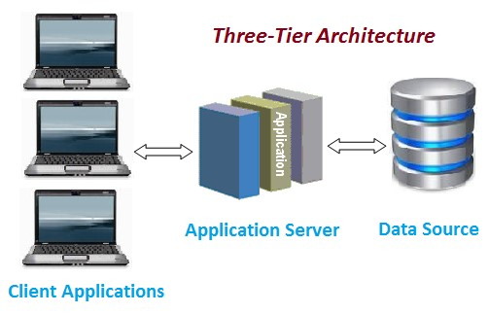

1.9. Gant chart:

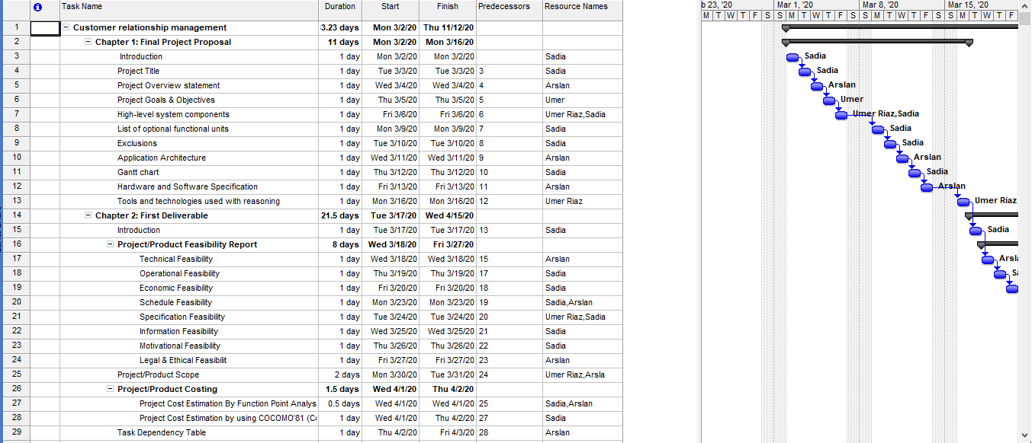

1.10. Hardware and Software Specification:
Hardware and software specifications that is required for developing and implementing this Project.

HARDWARE SPECIFICATION (Minimum)
Server side Hardware specification:
- Processor 2.0(core 2 due) GHz or faster
- RAM 3 GB or more
- Hard Disk Space 5 GB or above
- Internet connection via Cable or DSL (2Mbps or faster)

Client side Hardware Specification:
- Processor 2.0 GHz or faster
- RAM 1 GB or more
- Internet connection 1Mbps or better

SOFTWARE SPECIFICATION (Minimum)
Server side Software Specification:

- OS (Windows Server 2008 , 7, 8, 10, Server 2005 or above)
- Database (MS SQL Server 2012 or above)
- Browser that Support HTML 5 ,CSS 5 and JQuery, JQuery UI
- Framework (Asp.Net Core 1.0)
- Keyboard
- Monitor screen
- Mouse

Client side Software Specification:
- OS(Windows 7 ,8, 10,Vista)
- Web Browser (Internet Explorer, Mozilla Firefox, Google Chrome, Opera, Safari)
- Keyboard
- Monitor screen
- Mouse

1.11. Tools and technologies used with reasoning:

Documentation Tool:
- Microsoft Word(2013 or above)
- Microsoft Project.

Designing Tools:
- HTML and CSS for creating web pages and designing.
- PHP for backend Code Language.
- Bootstrap is used for designing web pages because design build in bootstrap is responsive and easy to manage.
- Adobe Photoshop also used for image manipulation in some cases.
MS Word
MS word allows the user to type the and save the document. We will use the MS word to create documentation of our project.

HTML
Hypertext markup language is the standard language for creation web pages and web application.
CSS
Cascading style sheet used for describing the presentation of a document written in a markup language.
PHP
PHP is a general-purpose scripting language that is used to web development for server side.
XAMPP
We will use XAMPP to test work on our own computer without any access to the internet.
MS Project 2007
Microsoft Office Project 2007 gives you robust project management tools with the right blend of usability, power, and flexibility to help you manage the projects more efficiently and effectively.
E-Draw Max
E-Draw Max is an all in one diagram software that makes it simple to create professional looking flowchart, organizational charts, network diagrams, business presentation, UML diagrams, building plans, database diagrams and more

Chapter 2: First Deliverable

2.1. Introduction

Support event management system is mainly focus on the selection of the students and participated in sports the students information will be saved in the database depend on the particular sports

- Project Feasibility
- Project Scope
- Project Costing
- Task Dependency Table
- Critical Path Method Analysis (CPM Analysis)
- Gantt Chart
- Introduction to team members
- Tasks and member assignment table
- Tools and Technologies
- Vision Document
- Risk List
- Product Features

2.2. Project/Product Feasibility Report
The main perspective of the project sports events management is the web application to successful, considering engineering, land use, financing, demand, and economic impact, incorporate cost benefit analysis.
- Location, construction cost, and engineering.
- Financing.
- Economic and fiscal impact.
There are many types of feasibilities:

- Technical
- Operational
- Economic
- Schedule
- Specification
- Information
- Motivational
- Legal and Ethical

2.2.1. Technical Feasibility
The criteria for technical feasibility of Online web application is:

Easy to use: The users were assumed to be normal ordinary people having knowledge of simple computer operation, so ease of use is a very essential factor if we want to get the job actually done quickly.

Security: As login name and passwords are used at login time so security is maintain. Some functions are to be kept under control of some specific authority so password protected entry is used.

Compatibility: Our web application makes it possible to extend an existing class or interface by adding new methods and properties.

Reliability: As tables are used for storing the data, so reliability is maintained as exact data is retrieved. Data is regained from each table by using a unique key so the accurate record is accessed.

Updating: As the project is built with keeping in mind all necessary functions so no essential updating is required. Features of used technology can be enhanced so that new layout of data reports can be produced as desired.

Portability: As the size of project code is enormous. It is a web application which can be moved and transferred. So a CD can be used to transfer it from one place to other. If required, then data can also be moved using secondary memory devices. So it is portable to a large extent.

Extensibility: The project is easily extensible as, Web languages support further editing, such as adding new functions, new representations or editing modules.

Re-usability: The extensibility and probability of this project would make it more reusable software.

Serviceability: This project will try to provide maximum possible service to the user. In our project the technical feasibility is considered up to a great extent. The project is build using web technology, which is freely available. Thus the problem of non- availability of technology is eradicates.

2.2.2. Operational Feasibility:
The project is operationally feasible. The main actors of this system are admin and participants, thus it should be kept in mind that these two actors performance makes the system more efficient.
Operation feasibility ensure that it takes care the management and the users support to the project.

2.2.3. Economic Feasibility
Justification for the benefit/cost relative to the project is to be measured in economic feasibility. Therefore, economic feasibility can be divided into two parts; cost estimates and benefit estimates. Cost estimates can further be alienated into development or acquisition costs (one time) and maintenance and operation costs (ongoing).

In order to find development costs, break the project into tasks and use the lifecycle cost models. Experienced costs gained from similar projects should then be used to make estimates. The function point metric should be calculated.

Benefit estimates enclose tangible benefits and intangible benefits. Tangible benefits would include reduced costs and increased revenues. However, information quality, job satisfaction, and external standing are examples of intangible benefits.

2.2.4. Schedule Feasibility:

After carrying out the schedule feasibility we are confident that the project will be accomplished within the allotted time. Time is very important factor. The assessment and evaluation of the completion of a project with available staff and resources within time is very essential. Meeting and mile stones should always be kept in mind.

2.2.5. Specification Feasibility:

Requirements are the features that the system must have or a constraint is that must be accepted for the customer. The question arises as to whether the requirements are clear definite. The scope boundaries must also be assessed.

2.2.6. Information Feasibility:

This website is reliable and meaningful for the end-users, admin and management. We are fully confident that information generated by website will be completed by all aspects and fulfill the user requirements.
The feasibility of information must be assessed regarding its completion, reliability, and meaningful.

2.2.7. Motivational Feasibility:

Evaluation of the client staff regarding the motivation to perform the necessary steps correctly and promptly must occur.

2.2.8. Legal & Ethical Feasibility
”Do any infringements or liabilities arise from this project? “ is the main focus of this feasibility.

2.3. Project/Product Scope
Scope is a very dominant factor. Scope and context are both intertwined as both involve the boundaries of a system. Context would be referring to what holds outside the boundary the system. While scope would indicate whatever is inside the boundary of the system.
Sport Event Management System is the application of project management to the creation and development of festivals and events.
- To find out the application of sport management system.
- To provide information and manage the system regarding sport events of the college.

2.4. Project/Product Costing

2.4.1. Project Cost Estimation By Function Point Analysis

Type of component Complexity of Components
 | Low | Average | High | Total
External Inputs | 6*3=18 | 6*4=24 | 4*6=24 | 66
External Output | 4*4=16 | 6*5=30 | 4*7=28 | 74
External Inquiries | 9*3=27 | 5*4=20 | 5*6=30 | 77
Internal Logical Files | 1*7=7 | 1*10=10 | 0*15=0 | 17
External Interface files | 2*5=10 | 0*7=0 | 0*10=0 | 10
Total Number of Unadjusted Function Points |  |  |  | 244

Sr. No | Factors | Fi Values
1 | Data communications | 4
2 | Distributed data processing | 0
3 | Performance | 2
4 | Heavily used configuration | 1
5 | Transaction rate | 3
6 | On-Line data entry | 4
7 | On-Line update | 4
8 | End-user efficiency | 4
9 | Complex processing | 3
10 | Reusability | 4
11 | Installation ease | 3
12 | Operational ease | 3
13 | Multiple sites | 1
14 | Facilitate change | 3
 | ∑ Fi | 39

To compute function points (FP), the following relationship is used:

FP est. = Count Total * [0.65 + 0.01 * (Fi)]
=244 * [0.65 + 0.01 * 39]
=244 * [0.65 + 0. 39]
=244 * 1.04
=253.76

The formulae are given as follows:

Cost / FP = labor rate / productivity parameter

Cost/FP=15000/25
Cost /FP=600

Total Project Cost = FP est. * (cost / FP)
=253.76*600
=152256

Total Estimated Effort = FP est. / productivity parameter
=253.76/25
=10.1504

Type of Complexity of Components
Component
 | Low | Average | High | Total
External Inputs | X3= | X4= | X6= | Total
External Outputs | X4= | X5= | X7= | Total
Internal Inquiries | X3= | X4= | X6= | Total
Internal Logical Files | X7= | X10= | X15= | Total
External Interface Files | X5= | X7= | X10= | Total
Total number of unadjusted
Function points
 | Multiplied value adjustment factor
Total Adjusted
Function Points

Information domain values are defined in the following manner:

Number of user inputs: Each user input that provides distinct application-oriented data to the software is counted. Inputs should be distinguished from inquiries, which are counted separately.

Number of user outputs: Each user output that provides application-oriented information to the user is counted. In this context output refers to reports, screens, error messages, etc. Individual data items within a report are not counted separately.

Number of user inquiries: An inquiry is defined ass an on-line input that results in the generation of some immediate software response in the form of an on-line output. Each distinct inquiry is counted.

Number of files: Each logical master file (i.e. a logical grouping of data that may be one part of a large database or a separate file) is counted.

Number of external interfaces: All the machine-readable interfaces (e.g., data files on storage media) that are used to transmit information to another system are counted.

Once these data have been collected, a complexity value is associated with each count. Organizations that use function point methods develop criteria for determining whether a particular entry is simple, average, or complex. Nonetheless, the determination of complexity is somewhat subjective.

To compute function points (FP), the following relationship is used:

FP est. = Count Total * [ 0.65 + 0.01 * (Fi)]

Where count total is the sum of all FP entries obtained from above figure and (Fi) is value adjustment factor (VAF) is based on 14 general system characteristics (GSC's) that rate the general functionality of the application being counted. Each characteristic has associated descriptions that help determine the degrees of influence of the characteristics. The degrees of influence range on a scale of zero to five, from no influence to strong influence.

1. Data communications
2. Distributed data processing
3. Performance
4. Heavily used configuration
5. Transaction rate
6. On-Line data entry
7. End-user efficiency
8. On-Line update
9. Complex processing
10. Reusability
11. Installation ease
12. Operational ease
13. Multiple sites
14. Facilitate change

Finally, Total Project Cost and Total Project Effort are calculated given the average productivity parameter for the system.

The formulae are given as follows:

Cost / FP = labor rate / productivity parameter

Total Project Cost = FP est. * (cost / FP)

Total Estimated Effort = FP est. / productivity parameter

2.4.2. Project Cost Estimation by using COCOMO’81 (Constructive Cost Model)
Boehm's COCOMO model is one of the mostly used models commercially. The first version of the model delivered in 1981 and COCOMO II is available now. COCOMO 81 is a model that allows one to estimate the cost, effort, and schedule when planning a new software development activity, according to software development practices that were commonly used in the 1970s through the 1980s. It exists in three forms, each one offering greater detail and accuracy the further along one is in the project planning and design process. Listed by increasing fidelity, these forms are called Basic, Intermediate, and Detailed COCOMO. However, only the Intermediate form has been implemented by USC in a calibrated software tool.
Three levels:

Basic: Is used mostly for rough, early estimates.
Intermediate: Is the most commonly used version, includes 15 different factors to account for the influence of various project attributes such as personnel capability, use of modern tools, hardware constraints, and so forth.
Detailed: Accounts for the influence of the different factors on individual project phases: design, coding/testing, and integration/testing. Detailed COCOMO is not used very often.

Each level includes three software development types:
- Organic: Relatively small software teams develop familiar types of software in an in-house environment. Most of the personnel have experience working with related systems.
- Embedded: The project may require new technology, unfamiliar algorithms, or an innovative new method
- Semi-detached: Is an intermediate stage between organic and embedded types.

Basic COCOMO
KLOC= (253.76 * 40)/1000
=10.15
PM= 2.4 (KLOC) ^1.05
=2.4(10.15) ^1.05
=2.4 * 11.40
=27.36

TD= 2.5(PM) ^0.38
=2.5(27.36) ^0.38
=2.5*3.52
=8.8

Type | Effort | Schedule
Organic | PM=27.36 | TD=8.8

The schedule is determined using the Basic COCOMO schedule equations.

People Required = Effort / Duration
=27.36/8.8
=3.11

2.5. Task Dependency Table
TASK ID | TASK | DURATION  (DAYS ) | PREDECESSORS
1 | Customer relationship management | 183
2 | Chapter 1: Final Project Proposal | 11
3 | Introduction | 1
4 | Project Title | 1 | 3
5 | Project Overview statement | 1 | 4
6 | Project Goals & Objectives | 1 | 5
7 | High-level system components | 1 | 6
8 | List of optional functional units | 1 | 7
9 | Exclusions | 1 | 8
10 | Application Architecture | 1 | 9
11 | Gantt chart | 1 | 10
12 | Hardware and Software Specification | 1 | 11
13 | Tools and technologies used with reasoning | 1 | 12
14 | Chapter 2: First Deliverable | 22
15 | Introduction | 1 | 13
16 | Project/Product Feasibility Report | 8
17 | Technical Feasibility | 1 | 15
18 | Operational Feasibility | 1 | 17
19 | Economic Feasibility | 1 | 18
20 | Schedule Feasibility | 1 | 19
21 | Specification Feasibility | 1 | 20
22 | Information Feasibility | 1 | 21
23 | Motivational Feasibility | 1 | 22
24 | Legal & Ethical Feasibilit | 1 | 23
25 | Project/Product Scope | 2 | 24
26 | Project/Product Costing | 2
27 | Project Cost Estimation By Function Point Analysis | 1 | 25
28 | Project Cost Estimation by using COCOMO’81 (Constructive Cost Model) | 1 | 27
29 | Task Dependency Table | 1 | 28
30 | CPM - Critical Path Method | 1 | 29
31 | Gantt chart | 1 | 30
32 | Introduction to Team member and their skill set | 1 | 31
33 | Task and Member Assignment Table | 1 | 32
34 | Tools and Technology with reasoning | 1 | 33
35 | Vision Document | 1 | 34
36 | Risk List | 1 | 35
37 | Product Features/ Product Decomposition | 1 | 36
38 | Chapter 3: Second Deliverable For Object Oriented Approach | 58
39 | Introduction | 1 | 37
40 | Systems Specifications | 1 | 39
41 | Existing System | 1 | 40
42 | Scope of the System | 1 | 41
43 | Summary of Requirements | 3 | 42
44 | Identifying External Entities | 3 | 43
45 | Capture "shall" Statements | 10 | 44
46 | Allocate Requirements | 10 | 45
47 | Priorities Requirements | 5 | 46
48 | Requirements Traceability Matrix | 5 | 47
49 | High Level Usecase Diagram | 3 | 48
50 | Usecase Description | 15 | 49
51 | Chapter 4: Third Deliverable For Object Oriented Approach | 21
52 | Introduction | 1 | 50
53 | Domain Model | 2 | 52
54 | System Sequence Diagram | 3 | 53
55 | Sequence Diagram | 3 | 54
56 | Collaboration Diagram | 3 | 55
57 | Design Class Diagram | 3 | 56
58 | State chart diagram | 3 | 57
59 | Data Model | 3 | 58
60 | Chapter 5: 2nd & 3rd Deliverable For structured Approach | 11
61 | Introduction | 1 | 59
62 | Entity Relationship Diagram | 3 | 61
63 | Data flow diagram (Functional Model) | 3 | 62
64 | State Transition Diagram | 3 | 63
65 | Component Level Design | 1 | 64
66 | Chapter 6: 4th Deliverable (User Interface Design) | 44
67 | Introduction | 1 | 65
68 | Site Maps | 2 | 67
69 | Story boards | 4 | 68
70 | Navigational maps | 4 | 69
71 | Development | 30 | 70
72 | Trace-ability Matrix | 3 | 71
73 | Chapter 7: 5th Deliverable (Software Testing) | 16
74 | Introduction | 1 | 72
75 | Test plan | 5 | 74
76 | Test Case Specification | 10 | 75

2.6. CPM - Critical Path Method
SR NO | ACTIVITY NAME | DUARATION  (Days) | ACTIVITY ID
1 | Chapter 1: Final Project Proposal | 17 | A
2 | Chapter 2: First Deliverable | 23 | B
3 | Chapter 3: Second Deliverable For Object  Oriented Approach | 37 | C
4 | Chapter 4: Third Deliverable For Object  Oriented Approach | 18 | D
5 | Chapter 5: 2nd & 3rd Deliverable For  structured Approach | 13 | E
6 | Chapter 6: Development | 24 | F
7 | Chapter 7: 4th Deliverable (User Interface Design) | 8 | G
8 | Chapter 8: 5th Deliverable (Software Testing) | 9 | H

SR NO | ACTIVITY ID | DUARATION  (Days) | PRECEDANCE
1 | A | 17
2 | B | 23 | A
3 | C | 37 | B
4 | D | 18 | C
5 | E | 13 | C
6 | F | 24 | D,E
7 | G | 8 | F
8 | H | 9 | G

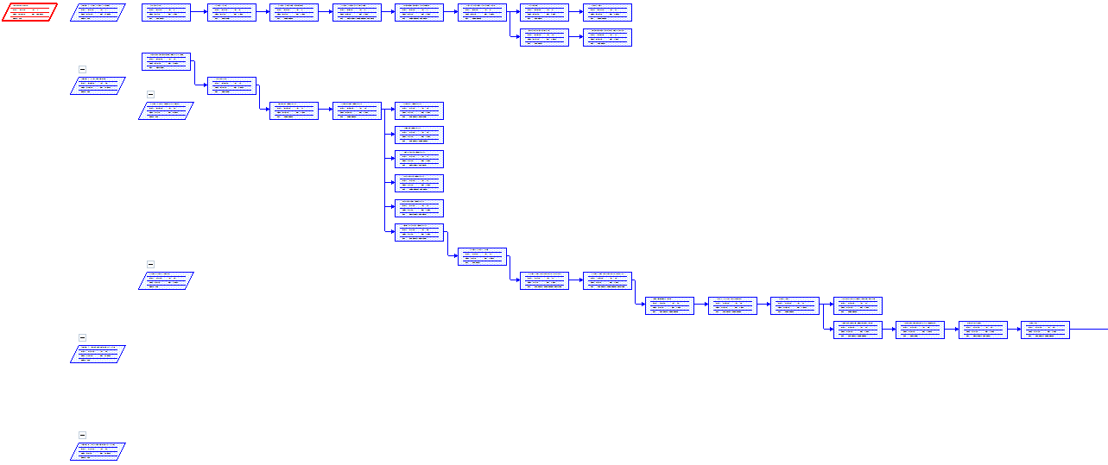

Activity | Duration | ES | EF | LS | LF | TS | FS
A | 5 | 0 | 5 | 0 | 5 | 0 | 0
B | 3 | 0 | 3 | 3 | 6 | 3 | 2
C | 8 | 5 | 13 | 5 | 13 | 0 | 0
D | 7 | 5 | 12 | 6 | 13 | 1 | 1
E | 7 | 0 | 7 | 6 | 13 | 6 | 6
F | 4 | 13 | 17 | 13 | 17 | 0 | 0
G | 5 | 17 | 22 | 17 | 22 | 0 | 0

The parameters and slacks are calculated as follows:

The critical path is:
A, B, C, E, F, G, H

2.6.3 IDENTIFY CRITICAL PATH DIAGRAM
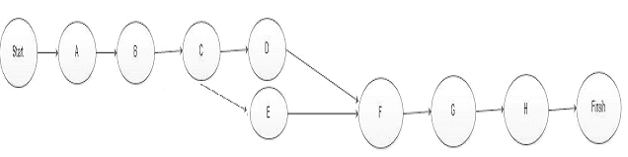

2.7. Gantt chart
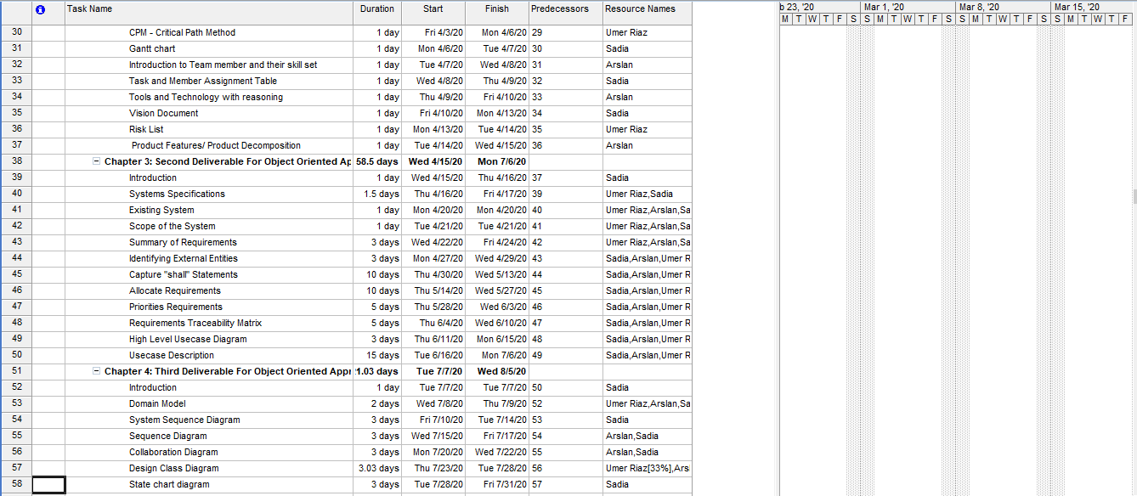
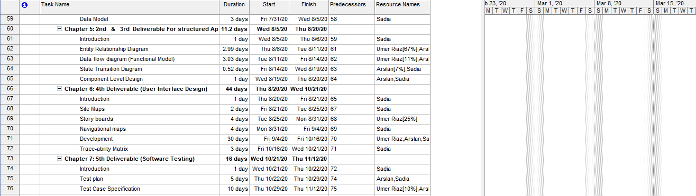

2.8. Introduction to Team member and their skill set
There are three members are involved in this project.
Sr No. | Members Name | Skills
M1 | Sadia Jamshaid | Grip on programming and coding, Android Coding, Testing, Documentation
M2 | Arslan Hashmi | Grip on PHP coding, Documentation, Requirements Analysis
M3 | Umer Riaz | Grip on HTML coding and CSS coding , Documentation

2.9. Task and Member Assignment Table
SR NO | Task | DUARATION  (Days) | PRECEDENCE
1 | Customer relationship management | 183
2 | Chapter 1: Final Project Proposal | 11
3 | Introduction | 1(M1) | Sadia
4 | Project Title | 1(M2) | Arslan
5 | Project Overview statement | 1(M3) | Umer Riaz
6 | Project Goals & Objectives | 1(M1) | Sadia
7 | High-level system components | 1(M1,M2) | Sadia, Arslan
8 | List of optional functional units | 1 | Umer Riaz
9 | Exclusions | 1 | Sadia
10 | Application Architecture | 1 | Sadia
11 | Gantt chart | 1 | Arslan
12 | Hardware and Software Specification | 1 | Sadia
13 | Tools and technologies used with reasoning | 1 | Sadia
14 | Chapter 2: First Deliverable | 22
15 | Introduction | 1 | Sadia
16 | Project/Product Feasibility Report | 8
17 | Technical Feasibility | 1 | Umer Riaz
18 | Operational Feasibility | 1 | Arslan
19 | Economic Feasibility | 1 | Sadia
20 | Schedule Feasibility | 1 | Sadia, Arslan
21 | Specification Feasibility | 1 | Sadia, Umer Riaz
22 | Information Feasibility | 1 | Sadia
23 | Motivational Feasibility | 1 | Sadia
24 | Legal & Ethical Feasibilit | 1 | Sadia
25 | Project/Product Scope | 2 | Sadia, Arslan
26 | Project/Product Costing | 2
27 | Project Cost Estimation By Function Point Analysis | 1 | Sadia
28 | Project Cost Estimation by using COCOMO’81 (Constructive Cost Model) | 1 | Arslan
29 | Task Dependency Table | 1 | Umer Riaz
30 | CPM - Critical Path Method | 1 | Sadia
31 | Gantt chart | 1 | Sadia
32 | Introduction to Team member and their skill set | 1 | Sadia
33 | Task and Member Assignment Table | 1 | Arslan
34 | Tools and Technology with reasoning | 1 | Arslan
35 | Vision Document | 1 | Sadia
36 | Risk List | 1 | Umer Riaz
37 | Product Features/ Product Decomposition | 1 | Sadia
38 | Chapter 3: Second Deliverable For Object Oriented Approach | 58
39 | Introduction | 1 | Sadia
40 | Systems Specifications | 1 | Sadia, Umer Riaz, Arslan
41 | Existing System | 1 | Sadia, Arslan, Umer Riz
42 | Scope of the System | 1 | Sadia, Arslan, Umer Riz
43 | Summary of Requirements | 3 | Sadia, Arslan, Umer Riz
44 | Identifying External Entities | 3 | Sadia, Arslan, Umer Riz
45 | Capture "shall" Statements | 10 | Sadia, Arslan, Umer Riz
46 | Allocate Requirements | 10 | Sadia, Arslan, Umer Riz
47 | Priorities Requirements | 5 | Sadia
48 | Requirements Traceability Matrix | 5 | Sadia
49 | High Level Usecase Diagram | 3 | Sadia, Arslan
50 | Usecase Description | 15 | Sadia, Arslan, Umer Riz
51 | Chapter 4: Third Deliverable For Object Oriented Approach | 21
52 | Introduction | 1 | Sadia
53 | Domain Model | 2 | Sadia, Arslan
54 | System Sequence Diagram | 3 | Sadia
55 | Sequence Diagram | 3 | Sadia
56 | Collaboration Diagram | 3 | Sadia, Arslan
57 | Design Class Diagram | 3 | Sadia[33%],Arslan[33%],Umer Riaz[33%]
58 | State chart diagram | 3 | Sadia
59 | Data Model | 3 | Sadia
60 | Chapter 5: 2nd & 3rd Deliverable For structured Approach | 11
61 | Introduction | 1 | Sadia
62 | Entity Relationship Diagram | 3 | Sadia[67%],Arslan[67%],Umer Riaz[67%]
63 | Data flow diagram (Functional Model) | 3 | Sadia[11%],Arslan[11%],Umer Riaz[11%]
64 | State Transition Diagram | 3 | Arslan, Umer Riaz[7%]
65 | Component Level Design | 1 | Sadia
66 | Chapter 6: 4th Deliverable (User Interface Design) | 44
67 | Introduction | 1 | Sadia
68 | Site Maps | 2 | Sadia
69 | Story boards | 4 | Arslan[25%]
70 | Navigational maps | 4 | Umer Riaz
71 | Development | 30 | Sadia, Arslan, Umer Riz
72 | Trace-ability Matrix | 3 | Sadia
73 | Chapter 7: 5th Deliverable (Software Testing) | 16
74 | Introduction | 1 | Sadia
75 | Test plan | 5 | Sadia, Arslan
76 | Test Case Specification | 10 | Sadia[10%],Arslan[10%],Umer Riaz[10%]

2.10. Tools and Technology with reasoning
2.10.1 MS Word:

MS word allows the user to type the and save the document. We will use the MS word
to create documentation of our project. The word app is use form Microsoft lets you
create, edit, view, and share your files with others quickly.

2.10.2 HTML:

Hypertext markup language is the standard language for creation web pages and web
application. It is used to describe the structure of webpages. It consist of a series of
elements. IT tells the browser how to display the content.

2.10.3 CSS:

Cascading Style Sheet used for describing the presentation of a document written in a
markup language. CSS describes how html elements are to be displayed on screen,
paper, or in order media. CSS saves as a lot of work.

2.10.4 PHP:
PHP is a general purpose scripting language that is need to web development for
server side. It is stand for hypertext preprocessor. It is widely used, free, and efficient
alternative to competitors such as Microsoft ASP.

2.10.5 XAMPP:

We will use XAMPP to test work on our own computer without any access to the
Internet. XAMPP is a free open source cross platform webserver solution stack
Package developed by apache friends, it is a simple, light weight apache distribution
that makes it extremely easy for developers to create local webserver for testing
purposes.

2.11. Vision Document
The vision is to develop the system to facilitate the colleges for sports events and can facilitate from previous record and saved online data in database. And save the good memories.

Sport administrator has the very important role in this system because he is the person which confirm and cancel the selection of the participants through a system.

He will responsible to manage the participants activities, games, appraisal as well as their personal information in an efficient manner. The main vision of this software to reduced the effort of colleges to manage the further sport events activities.

2.12. Risk List:
There are some reasons due to which risk occur:

 | RISK | SOLUTION
1 | Project time may increase than given time. | Increase number of members to manage time complexity.
2 | Tools member may not be available. | Hire new members.
3 | Tools may not be available. | Purchase your own tools or alternative tools will be used.
4 | Exception loss. | Ensure the code, remove errors.
5 | Risk due the complexity of the project | Easy to understand
6 | Project Inefficient | Project will be efficient by using technologies.
7 | Project running over project. | Project will be running within budget.

2.13. Product Features/ Product Decomposition

There are some product features are as follows:

- Thoughtful.
- Power search site.
- Useful.
- Easy to assessable.
- Meaningful.
- User friendly layout.
- Unique.

Chapter 3: Second Deliverable For Object Oriented Approach

3.1 Introduction:
Requirements engineering process provides the appropriate mechanism for understanding what the customer wants, analyzing need, assessing feasibility, negotiating a reasonable solution, specifying the solution unambiguously, validating the specification and managing the requirements as they are transformed into an operational system. The task of capturing, structuring, and accurately representing the user's requirements so that they can be correctly embodied in systems which meet those requirements (i.e. are of good quality).

- Requirements elicitation
- Requirements analysis and negotiation
- Requirements specification
- System modeling
- Requirements validation
- Requirements management

Here, requirements specification is to be discussed. Requirements specification would lead to the following four steps:
- Identify external interfaces
- Development of context diagram
- Capture “shall statements
- Allocate requirements
- Prioritize requirements
- Development of requirements traceability matrix

3.1.1 Systems Specifications
The following are the clauses that must be included while describing the system specifications.

3.1.2 Introduction
This clause should contain brief “Introduction” of the system under discussion domain knowledge. It can also contain company, its location, its historical background and its current status in the market. The most important part of this clause is to give an overview of the major business areas of the company. This overview must be very brief so that one can get a bird’s eye view of the organization under study.

3.1.3 Existing System
This clause must be focusing on providing a comprehensive detail of main business areas of the organizations that we have just mentioned in the previous clause. But here the discussion should be more elaborative.

3.1.4 Organizational Chart
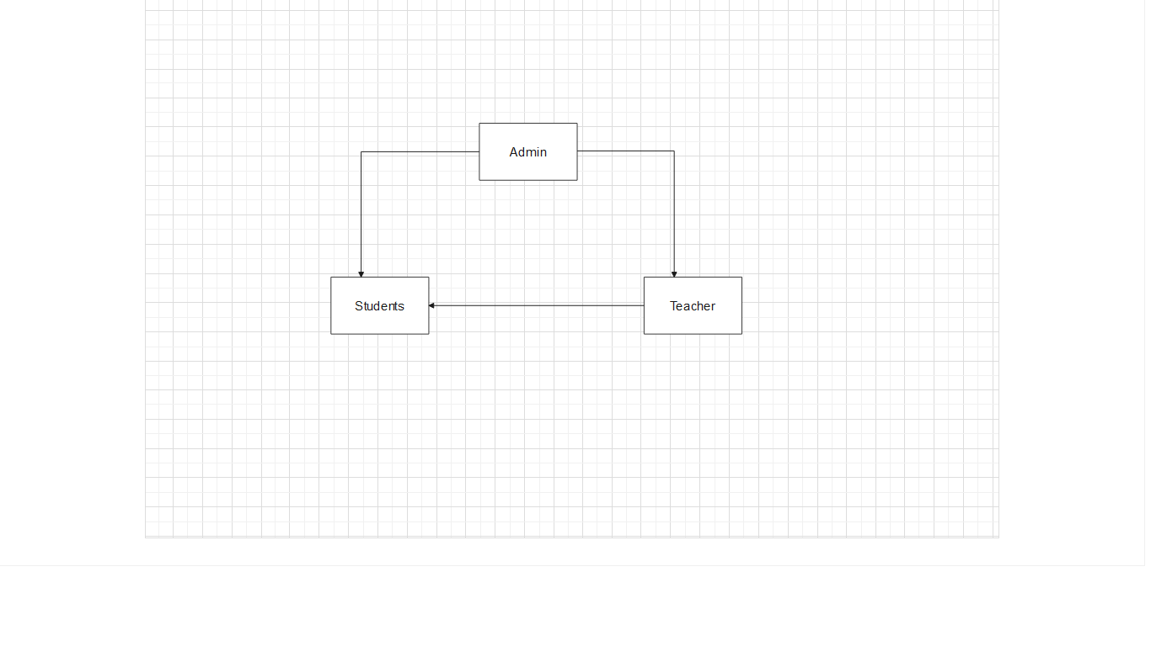

3.1.5 Scope of the System
The Scope may include the boundaries of the system under study. To what domain you want to restrict your project must be clearly mentioned in this clause.

3.1.6 Summary of Requirements: (Initial Requirements)
Admin
- Login and Logout
- View information
- Manage Event
- Manage Crowed
- Add the Student details
- Add the Teacher details
Teachers
- Generate Result
- Check the profile
- Select Games
- Perform Duties
- Take Attendance
Students
- Get Registration Event
- Take Participates in event
- View Schedule

3.1.7. Identifying External Entities:
The Identification of External Entities is done in two phases.
a. Over Specify Entities from Abstract:
1. Admin
2. Teacher
3. Students
4. Participants
5. Records
6. Position holder
b. Perform Refinement:
1. Admin
2. Students
3. Teachers
4. Participants

3.1.8. Context Level Data Flow Diagram:

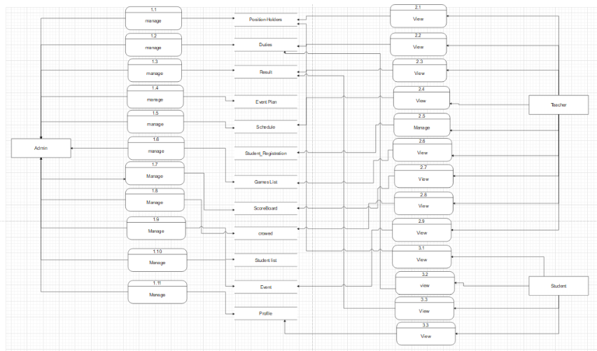

3.1.9. Capture "shall" Statements:

Paragraph # |  | Initial Requirements
1.01 |  | The Application "Shall" facilitate the admin to login
1.02 |  | The Application "Shall" facilitate the admin to create the event
1.03 |  | The Application "Shall" facilitate the admin to Edit plan
1.04 |  | The Application "Shall" facilitate the admin to View plan
1.05 |  | The Application "Shall" facilitate the admin to event plan
1.06 |  | The Application "Shall" facilitate the admin to assigned duties or activities
1.07 |  | The Application "Shall" facilitate the admin to add teacher information
1.08 |  | The Application "Shall" facilitate the admin to add student information
1.09 |  | The Application "Shall" facilitate the admin to add participants
1.1 |  | The Application "Shall" facilitate the admin to remove participants
1.11 |  | The Application "Shall" facilitate the admin to view games
1.12 |  | The Application "Shall" facilitate the admin to add games
1.13 |  | The Application "Shall" facilitate the admin to select games
1.14 |  | The Application "Shall" facilitate the admin to view attendance
1.15 |  | The Application "Shall" facilitate the admin to update attendance
1.16 |  | The Application "Shall" facilitate the admin to view scorecard
1.17 |  | The Application "Shall" facilitate the admin to save record
1.18 |  | The Application "Shall" facilitate the admin to view record
1.19 |  | The Application "Shall" facilitate the admin to delete record
1.2 |  | The Application "Shall" facilitate the admin to view results
1.21 |  | The Application "Shall" facilitate the admin to organized event
1.22 |  | The Application "Shall" facilitate the admin to make schedule
1.23 |  | The Application "Shall" facilitate the admin to view schedule
1.24 |  | The Application "Shall" facilitate the admin to update schedule
1.25 |  | The Application "Shall" facilitate the admin to view student register
1.26 |  | The Application "Shall" facilitate the admin to add event type
1.27 |  | The Application "Shall" facilitate the admin to update teacher list
1.28 |  | The Application "Shall" facilitate the admin to delete teacher detail
1.29 |  | The Application "Shall" facilitate the admin to view events
1.3 |  | The Application "Shall" facilitate the admin to view results
1.31 |  | The Application "Shall" facilitate the admin to change password
1.32 |  | The Application "Shall" facilitate the admin to change activities
1.33 |  | The Application "Shall" facilitate the admin to logout
1.34 |  | The Application "Shall" facilitate the teacher to login
1.35 |  | The Application "Shall" facilitate the teacher to take attendance
1.36 |  | The Application "Shall" facilitate the teacher to view attendance
1.37 |  | The Application "Shall" facilitate the teacher to select students
1.38 |  | The Application "Shall" facilitate the teacher to view games
1.39 |  | The Application "Shall" facilitate the teacher to view scorecard
1.4 |  | The Application "Shall" facilitate the teacher to view records
1.41 |  | The Application "Shall" facilitate the teacher to view results
1.42 |  | The Application "Shall" facilitate the teacher to generate result
1.43 |  | The Application "Shall" facilitate the teacher to change password
1.44 |  | The Application "Shall" facilitate the teacher to select games
1.45 |  | The Application "Shall" facilitate the teacher to perform duties or activity
1.46 |  | The Application "Shall" facilitate the teacher to view plan
1.47 |  | The Application "Shall" facilitate the teacher to view event
1.48 |  | The Application "Shall" facilitate the teacher to logout
1.49 |  | The Application "Shall" facilitate the student to login
1.5 |  | The Application "Shall" facilitate the student to view event
1.51 |  | The Application "Shall" facilitate the student to get registration event
1.52 |  | The Application "Shall" facilitate the student to view schedule
1.53 |  | The Application "Shall" facilitate the student to view attendance
1.54 |  | The Application "Shall" facilitate the student to view records
2.01 |  | The Application "Shall" facilitate the student to view games
2.02 |  | The Application "Shall" facilitate student to select games
2.03 |  | The Application "Shall" facilitate the student to view result
2.04 |  | The Application "Shall" facilitate the student to change password
2.05 |  | The Application "Shall" facilitate the student to logout

3.1.10. Allocate Requirements:
Para # | Initial Requirement | Use Case Name
1 | Admin “shall” Login | UC _ Admin _ Login
2 | Teacher “shall” Login | UC_ Teacher_ Login
3 | Students “shall” Login | UC_ Students _Login
4 | Admin “shall” View Event | UC_ Admin _ View Event
1.1 | Admin “shall” Create Event | UC_ Admin _Create Event
1.2 | Admin “shall” Manage Event | UC_ Admin _ Manage Event
1.3 | Admin “shall” Manage Scoreboard | UC_ Admin _ Manage Score Board
1.4 | Admin “shall” View Games | UC_ Admin _View Games
1.5 | Admin “shall” View Schedule | UC_ Admin _ View Schedule
1.6 | Admin “shall” View Records | UC_ Admin _ View Records
1.9 | Admin “shall” Update Record | UC_ Admin _Update Record
1.1 | Admin “shall” View Student Registration | UC_ Admin _View Student Registration
1.11 | Admin “shall” View Event Plan | UC_ Admin _ View Event Plan
1.12 | Admin “shall” View Attendance | UC_ Admin _ View Attendance
1.13 | Admin “shall” Select Games | UC_ Admin _ Select Games
1.14 | Admin “shall” Add Games | UC_ Admin _ Add Games
1.15 | Admin “shall” Change Activities | UC_ Admin _ Change Activities
1.16 | Admin “shall” Change Password | UC_ Admin _Change Password
1.17 | Students “shall” Get Registration Event | UC _Students _ Get Registration Event
2.1 | Student “shall” View Event | UC_ Students_ View Event

3.1.11. Prioritize Requirements:
Para # | Rank | Initial Requirement | Use Case ID | Use Case Name
1 | Highest | Admin “shall” Login | UC_3.1.14.1 | UC _ Admin _ Login
2 | Highest | Teacher “shall” Login | UC_3.1.14.1 | UC_ Teacher_ Login
3 | Highest | Students “shall” Login | UC_3.1.14.1 | UC_ Students _Login
4 | Medium | Admin “shall” View Event | UC_3.1.14.16. | UC_ Admin _ View Event
1.1 | Medium | Admin “shall” Create Event | UC_3.1.14.9 | UC_ Admin _Create Event
1.2 | Medium | Admin “shall” Manage Event | UC_3.1.14.37 | UC_ Admin _ Manage Event
1.3 | Medium | Admin “shall” Manage Scoreboard | UC_3.1.14.38 | UC_ Admin _ Manage Score Board
1.4 | Medium | Admin “shall” View Games | UC_3.1.14.22 | UC_ Admin _View Games
1.5 | Medium | Admin “shall” View Schedule | UC_3.1.14.20 | UC_ Admin _ View Schedule
1.6 | Medium | Admin “shall” View Records | UC_3.1.14.18 | UC_ Admin _ View Records
1.9 | Medium | Admin “shall” Update Record | UC_3.1.14.6 | UC_ Admin _Update Record
1.1 | Medium | Admin “shall” View Student Registration | UC_3.1.14.9 | UC_ Admin _View Student Registration
1.11 | Medium | Admin “shall” View Event Plan | UC_3.1.14.35 | UC_ Admin _ View Event Plan
1.12 | Medium | Admin “shall” View Attendance | UC_3.1.14.32 | UC_ Admin _ View Attendance
1.13 | Lowest | Admin “shall” Select Games | UC_3.1.14.23 | UC_ Admin _ Select Games
1.14 | Lowest | Admin “shall” Add Games | UC_3.1.14.24 | UC_ Admin _ Add Games
1.15 | Lowest | Admin “shall” Change Activities | UC_3.1.14.2 | UC_ Admin _ Change Activities
1.16 | Lowest | Admin “shall” Change Password | UC_3.1.14.3 | UC_ Admin _Change Password
1.17 | Highest | Students “shall” Get Registration Event | UC_3.1.14.31 | UC _Students _ Get Registration Event
2.1 | Highest | Student “shall” View Event | UC_3.1.14.16 | UC_ Students_ View Event

3.1.12. High Level Usecase Diagram:
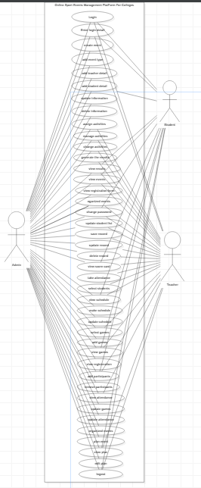

3.1.13. Analysis Level Usecase Diagram:
Admin:
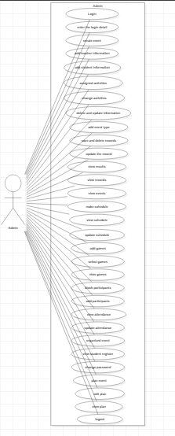

Student:
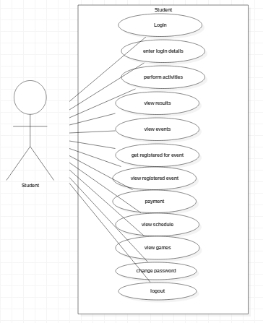

Teacher:
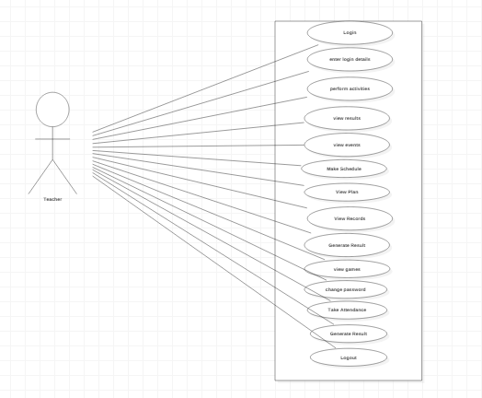

3.1.14. Usecase Description

UC-3.1.14.1: Make Login
Actors: Member ( Admin, Teacher, Students)
Feature: Make Login.
Use case Id: |  | UC-3.1.14.1
Pre-condition: |  | Member Should be valid account
Scenarios
Step# | Action |  |  | Software Reaction
1. | Member will use the URL. |  |  | System will open the site
2. | Member will request to make login page. |  |  | System will display the login page.
3. | Member will enter the login detail |  |  | System will validate and verify the details.
4. | . |  |  | System will Update the login page.
Alternate Scenarios:
1. If the connection will be lost, dashboard will fail to display.
5. If the system is not support the activity, activity will not be changed.
Post Conditions
Step# | Description
1. | Make login successfully.
Use Case Cross referenced
User Interface reference

UC-3.1.14.2: Change Activity
Actors: Member ( Admin)
Feature: Change Activity.
Use case Id: |  | UC-3.1.14.2
Pre-condition: |  | Member Should be make activities list.
Scenarios
Step# | Action |  |  | Software Reaction
1. | Member will request to the login form. |  |  | System will display login form.
2. | Member will enter the login details. |  |  | System will validate and verify the details.
3. |  |  |  | System will display the dashboard.
4. | Member will request to change the activity. |  |  | System will display the activity list.
5. | Member will change the activity. |  |  | System will change the activity.
6. |  |  |  | System will display the dashboard.
7. |  |  |  | System will done the activity.
Alternate Scenarios:
1. If the connection will be lost, dashboard will fail to display.
5. If the system is not support the activity, activity will not be changed.
Post Conditions
Step# | Description
1. | Activity is changed successfully.
Use Case Cross referenced
User Interface reference

UC-3.1.14.3.: Change Password
Actors: Member ( Admin, Teacher, Students )
Feature: Change Password
Use case Id: |  | UC-3.1.14.3
Pre-condition: |  | Member Should have change password.
Scenarios
Step# | Action |  | Software Reaction
1. | Member will request to login form. |  | System will display login form.
2. | Member will enter the login details. |  | System will validate and verify the details.
3. |  |  | System will display the dashboard.
4. | Member will request to change the password. |  | System will give the permission to change the password and will display the dashboard.
5. | Member will enter the old password. |  | System will validate and verify the details.
6. |  |  | System will display the dashboard.
7. | Member will enter the current password. |  | System will validate and verify the details.
8. |  |  | System will change the password.
Alternate Scenarios: if you forgot the email password then you should have make the new email id and you save your current password.
1. If the connection will be lost, dashboard will fail to display.
5. If the requirements are not fulfill, password will not be changed.
Post Conditions
Step# | Description
1. | password is changed successfully.

UC-3.1.14.4: Update Student List
Actors: Member ( Admin)
Feature: Update Student List.
Use case Id: |  | UC-3.1.14.4
Pre-condition: |  | Member Should have make a list.
Scenarios
Step# | Action |  | Software Reaction
1. | Member will request to the login. |  | System will display login form.
2. | Member will enter the login details. |  | System will validate and verify the details.
3. |  |  | System will display the dashboard.
4. | Member will request to update the student list |  | System will display the Student list.
5. | Member will Update the student list. |  | System will update the student list.
6. |  |  | System will save the update list.
Alternate Scenarios: 1. if you don’t want to change or update the student list then you should make the new student list and save that list in system for further use.
1. If the connection will be lost, dashboard will fail to display.
5. If the list is not made, student list will not be changed.
Post Conditions
Step# | Description
1. | Student list is update successfully.

UC-3.1.14.5: Delete Record
Actors: Member ( Admin)
Feature: Delete Record.
Use case Id: |  | UC-3.1.14.5
Pre-condition: |  | Member Should be saved record.
Scenarios
Step# | Action |  | Software Reaction
1. | Member will request to login. |  | System will display login form.
2. | Member will enter the login details. |  | System will validate and verify the details.
3. |  |  | System will display the dashboard.
4. | Member will request to delete the record. |  | System will display the record.
5. | Member will delete the record. |  | System will delete the record.
Alternate Scenarios:
1. If the connection will be lost, dashboard will fail to display.
5. If the record is not saved, record will not be delete.
Post Conditions
Step# | Description
1. | Record is deleted successfully.

UC-3.1.14.6: Update Record
Actors: Member ( Admin)
Feature: Update Record.
Use case Id: |  | UC-3.1.14.6
Pre-condition: |  | Member Should be login first.
Scenarios
Step# | Action |  | Software Reaction
1. | Member will request to the login. |  | System will display login form.
2. | Member will enter the login details. |  | System will validate and verify the details.
3. |  |  | System will display the dashboard.
5. | Member will Update the record. |  | System will update the order.
6. |  |  | System will save the new record
Alternate Scenarios:
1. If the connection will be lost, dashboard will fail to display.
5. If the record is not save, record will not be update.
Post Conditions
Step# | Description
1. | Record is updated successfully.

UC-3.1.14.7: Take Attendance
Actors: Member (Teacher )
Feature: Take Attendance.
Use case Id: |  | UC-3.1.14.7
Pre-condition: |  | Member Should must be login.
Scenarios
Step# | Action |  | Software Reaction
1. | Member will request to login. |  | System will display login form.
2. | Member will enter the login details. |  | System will validate and verify the details.
3. |  |  | System will display the dashboard.
4. | Member will request to take the attendance. |  | System will display the attendance register.
5. | Member will take the attendance. |  | System will save the attendance.
Alternate Scenarios:
1. If the connection will be lost, dashboard will fail to display.
5. If the attendance register is not show, attendance will not be taken.
Post Conditions
Step# | Description
1. | Take the Attendance successfully.

UC-3.1.14.8: View Result
Actors: Member ( Admin, Teacher, Students )
Feature: View Result.
Use case Id: |  | UC-3.1.14.8
Pre-condition: |  | Member Should be generate the result.
Scenarios
Step# | Action |  | Software Reaction
1. | Member will request to login. |  | System will display login form.
2. | Member will enter the login details. |  | System will validate and verify the details.
3. |  |  | System will display the dashboard.
4. | Member will request to generate the result. |  | System will generate the result.
5. | Member will request to view the result. |  | System will display the result.
6. | Member will view the result.
Alternate Scenarios:
1. If the connection will be lost, dashboard will fail to display.
5. If the result is not generate, result will not be viewed.
Post Conditions
Step# | Description
1. | Result is viewed successfully.

UC-3.1.14.9: View Student Registration
Actors: Member ( Admin )
Feature: View Student Registration.
Use case Id: |  | UC-3.1.14.9
Pre-condition: |  | Member Should must be login.
Scenarios
Step# | Action |  | Software Reaction
1. | Member will request to login. |  | System will display login form.
2. | Member will enter the login details. |  | System will validate and verify the details.
3. |  |  | System will display the dashboard.
4. | Member will request to registration form. |  | System will display the registration form.
5. | Member will enter the registration details. |  | System will validate and verify the details.
6. |  |  | System will display the dashboard.
7. | Member will request to view the student registration form |  | System will display the registration form.
8. | Member will viewed the student registration.
Alternate Scenarios:
1. If the connection will be lost, dashboard will fail to display.
5. If the requirements are not fulfill, registration will not be viewed.
Post Conditions
Step# | Description
1. | View Student Registration successfully.

UC-3.1.14.10: Add Teacher Information
Actors: Member ( Admin )
Feature: Add Teacher Information.
Use case Id: |  | UC-3.1.14.10
Pre-condition: |  | Member Should be create the teacher table.
Scenarios
Step# | Action |  | Software Reaction
1. | Member will request to login. |  | System will display login form.
2. | Member will enter the login details. |  | System will validate and verify the details.
3. |  |  | System will display the dashboard.
4. | Member will request to add detail. |  | System will display the teacher table.
5. | Member will enter the teacher details in teacher table. |  | System will be enter the teacher detail.
6. | Member will save the detail. |  | System will be save detail.
7. | Member will request to view the teacher table. |  | System will display the teacher table.
Alternate Scenarios:
1. If the connection will be lost, dashboard will fail to display.
5. If the details is not accurate, detail will not be saved.
Post Conditions
Step# | Description
1. | Add teacher information successfully.

UC-3.1.14.11: Create Event
Actors: Member ( Admin )
Feature: Create Event.
Use case Id: |  | UC-3.1.14.11
Pre-condition: |  | Member Should must be login first.
Scenarios
Step# | Action |  | Software Reaction
1. | Member will request to login. |  | System will display login form.
2. | Member will enter the login details. |  | System will validate and verify the details.
3. |  |  | System will display the dashboard.
4. | Member will request to add the type of event. |  | System will display the event type (Indoor, Outdoor).
5. | Member will select the type of event.
6. | Member will add the event type.
Alternate Scenarios:
1. If the connection will be lost, dashboard will fail to display.
5. If the types are not select. Event type will not be add and may be event not create.
Post Conditions
Step# | Description
1. | Create Event Successfully.

UC-3.1.14.12: Add Student Information
Actors: Member ( Admin )
Feature: Add Student Information.
Use case Id: |  | UC-3.1.14.12
Pre-condition: |  | Member Should be create the student table.
Scenarios
Step# | Action |  | Software Reaction
1. | Member will request to login. |  | System will display login form.
2. | Member will enter the login details. |  | System will validate and verify the details.
3. |  |  | System will display the dashboard.
4. | Member will request to add the student details. |  | System will display the student table.
5. | Member will enter the details. |  | System will enter the details.
6. | Member will be save the detail. |  | System will be saved the detail.
Alternate Scenarios:
1. If the connection will be lost, dashboard will fail to display.
5. If the details is not accurate, detail will not be added.
Post Conditions
Step# | Description
1. | Student detail is add successfully.

UC-3.1.14.13: Update Teacher Information
Actors: Member ( Admin )
Feature: Logout.
Use case Id: |  | UC-3.1.14.13
Pre-condition: |  | Member Should be save the information.
Scenarios
Step# | Action |  | Software Reaction
1. | Member will request to login |  | System will display the login page.
2. |  |  | System will display the dashboard.
3. | Member will request to the update information. |  | System will display the teacher table.
4. | Member will update information. |  | System will update information.
Alternate Scenarios:
1. If the connection will be lost, dashboard will fail to display.
5. If the teacher table is not made, information will not be changed.
Post Conditions
Step# | Description
1. | Table update is successfully.

UC-3.1.14.14: Delete Information(Teacher)
Actors: Member ( Admin)
Feature: Delete Information(Teacher)
Use case Id: |  | UC-3.1.14.14
Pre-condition: |  | Member Should be login
Scenarios
Step# | Action |  | Software Reaction
1. | Member will request to login. |  | System will display the login form.
2. | Member will enter the details. |  | System will validate and verify the login details.
3. |  |  | System will display the dashboard.
4. | Member will request to delete the information. |  | System will display the teacher table.
5. | Member will delete the required information. |  | System will be delete the information.
Alternate Scenarios:
1. If the connection will be lost, dashboard will fail to display.
5. If the table is not made, information will not be delete.
Post Conditions
Step# | Description
1. | Member will delete information successfully.

UC-3.1.14.15: Delete Information(Student)
Actors: Member ( Admin)
Feature: Delete Information(Student)
Use case Id: |  | UC-3.1.14.15
Pre-condition: |  | Member Should be login
Scenarios
Step# | Action |  | Software Reaction
1. | Member will request to login. |  | System will display the login form
2. | Member will enter the login details. |  | System will validate and verify the details.
3. |  |  | System will display the dashboard.
3. | Member will request to delete the information. |  | System will display the Student table.
4. | Member will delete the required information. |  | System will be delete the information.
Alternate Scenarios:
1. If the connection will be lost, dashboard will fail to display.
5. If the table is not made, information will not be delete.
Post Conditions
Step# | Description
1. | Member will delete information successfully.

UC-3.1.14.16: View Sport Event
Actors: Member ( Admin, Teacher, Students )
Feature: View Sport Event.
Use case Id: |  | UC-3.1.14.16
Pre-condition: |  | Member Should be login
Scenarios
Step# | Action |  | Software Reaction
1. | Member will request to login form. |  | System will display the login form.
2. | Member will enter the details. |  | System will validate and verify the detail.
3. |  |  | System will display the dashboard.
4. | Member will request to view the event. |  | System will display the event.
Alternate Scenarios:
1. If the connection will be lost, dashboard will fail to display.
5. If the event is not create, event will not be viewed.
Post Conditions
Step# | Description
1. | View event is successfully.

UC-3.1.14.17: Save Record
Actors: Member ( Admin)
Feature: Save Record.
Use case Id: |  | UC-3.1.14.17
Pre-condition: |  | Member Should be login first.
Scenarios
Step# | Action |  | Software Reaction
1. | Member will request to the login. |  | System will display login form.
2. | Member will enter the login details. |  | System will validate and verify the details.
3. |  |  | System will display the dashboard.
4. | Member will request to save the record. |  | System will save the record.
Alternate Scenarios:
1. If the connection will be lost, dashboard will fail to display.
5. If the record is not made, record will not be saved
Post Conditions
Step# | Description
1. | Saved record successfully.

UC-3.1.14.18: View Records
Actors: Member ( Admin, Teacher )
Feature: View Records.
Use case Id: |  | UC-3.1.14.18
Pre-condition: |  | Member Should be login.
Scenarios
Step# | Action |  | Software Reaction
1. | Member will request to login. |  | System will display the login page.
2. | Member will enter the login detail. |  | System will validate and verify the details.
3. |  |  | System will display the dashboard.
4. | Member will request to view the records, |  | System will display the records
5. | Member will be view the record.
Alternate Scenarios:
1. If the connection will be lost, dashboard will fail to display.
5. If the record is not saved, record will not be view.
Post Conditions
Step# | Description
1. | View record successfully.

UC-3.1.14.19: Make Schedule
Actors: Member ( Admin)
Feature: Make Schedule.
Use case Id: |  | UC-3.1.14.19
Pre-condition: |  | Member Should be login
Scenarios
Step# | Action |  | Software Reaction
1. | Member will request to login. |  | System will display the login form.
2. | Member will enter the login details. |  | System will validate and verify the details.
3. |  |  | System will display the dashboard.
4. | Member will request to make the schedule. |  | System will display the schedule form.
Alternate Scenarios:
1. If the connection will be lost, dashboard will fail to display.
5. If the schedule is not made, system will display the error.
Post Conditions
Step# | Description
1. | Member will make schedule successfully.

UC-3.1.14.20: View Schedule
Actors: Member ( Admin, Teacher, Students )
Feature: View Schedule.
Use case Id: |  | UC-3.1.14.20
Pre-condition: |  | Member Should be login
Scenarios
Step# | Action |  | Software Reaction
1. | Member will request to login. |  | System will display the login form.
2. | Member will enter the login details. |  | System will validate and verify the details.
3. |  |  | System will display the dashboard.
4. | Member will request to view schedule. |  | System will display the schedule form.
Alternate Scenarios:
1. If the connection will be lost, dashboard will fail to display.
5. If the schedule is not made, schedule will not be view.
Post Conditions
Step# | Description
1. | View schedule successfully

UC-3.1.14.21: Update Schedule
Actors: Member ( Admin)
Feature: Update Schedule.
Use case Id: |  | UC-3.1.14.21
Pre-condition: |  | Member Should be login
Scenarios
Step# | Action |  | Software Reaction
1. | Member will request to login. |  | System will display the login form.
2. | Member will enter the login detail. |  | System will validate and verify the login detail.
3. |  |  | System will display the dashboard.
4. | Member will request to update the schedule. |  | System will display the schedule form.
5. | Member will update the schedule. |  | System will update the schedule.
Alternate Scenarios:
1. If the connection will be lost, dashboard will fail to display.
5. If the order is not made, order will not be changed.
Post Conditions
Step# | Description
1. | Update schedule is successfully.

UC-3.1.14.22: View Games
Actors: Member ( Admin, Teacher )
Feature : .View Games
Use case Id: |  | UC-3.2.12.22
Pre-condition: |  | Member Should be login
Scenarios
Step# | Action |  | Software Reaction
1. | Member will request to login |  | System will display the login form.
2. | Member will enter the login details |  | System will validate and verify the detail.
3. |  |  | System will display the dashboard.
4. | Member will request to views the games. |  | System will display the games list.
5. | Member will view the games.
Alternate Scenarios:
1. If the connection will be lost, dashboard will fail to display.
5. If the games list is not available, games will not be view.
Post Conditions
Step# | Description
1. | View games are successfully.

UC-3.1.14.23: Get Registration event
Actors: Member (Student)
Feature: Get Registration Event.
Use case Id: |  | UC-3.2.12.23
Pre-condition: |  | Member Should be login
Scenarios
Step# | Action |  | Software Reaction
1. | Member will request to login form. |  | System will display the login form.
2. | Member will enter the details. |  | System will validate and verify the detail.
3. |  |  | System will display the dashboard.
4. | Member will request to get the registration event. |  | System will be show the registration event.
Alternate Scenarios:
1. If the connection will be lost, dashboard will fail to display.
5. If the registration event is not show, student should not be get.
Post Conditions
Step# | Description
1. | Get Registration Event is successfully.

UC-3.1.14.24: Select Games
Actors: Member ( Admin, Teacher )
Feature : Select Games
Use case Id: |  | UC-3.2.12.24
Pre-condition: |  | Member Should be login
Scenarios
Step# | Action |  | Software Reaction
1. | Member will request to login |  | System will display the login form.
2. | Member will enter the login details |  | System will validate and verify the detail.
3. |  |  | System will display the dashboard.
4. | Member will request to select the games. |  | System will display the games list.
5. | Member will select the games. |  | System will select the games.
Alternate Scenarios:
1. If the connection will be lost, dashboard will fail to display.
5. If the games list is not available, games will not be view.
Post Conditions
Step# | Description
1. | Select games are successfully.

UC-3.1.14.25: Logout
Actors: Member ( Admin, Teacher, Students )
Feature: Logout.
Use case Id: |  | UC-3.2.12.25
Pre-condition: |  | Member Should be login
Scenarios
Step# | Action |  | Software Reaction
1. | Member will request the logout |  | System will logout
2. |  |  | System will display the dashboard.
Alternate Scenarios:
1. If the connection will be lost, dashboard will fail to display.
5. If the members are not login, system will not be logout.
Post Conditions
Step# | Description
1. | Member will logout successfully

Chapter 4: Third Deliverable For Object Oriented Approach

4.1. Introduction:
Third deliverable is all about the software design. In the previous deliverable, analysis of the system is completed. So we understand the current situation of the problem domain. Now we are ready to strive for a solution for the problem domain by using object-oriented approach. Following artifacts must be included in the 3rd deliverable.

- Domain Model
- System Sequence Diagram
- Sequence Diagram
- Collaboration Diagram
- Operation Contracts
- Design Class Diagram
- State Transition Diagram
- Data Model

Now we discuss these artifacts one by one as follows:

4.2. Domain Model
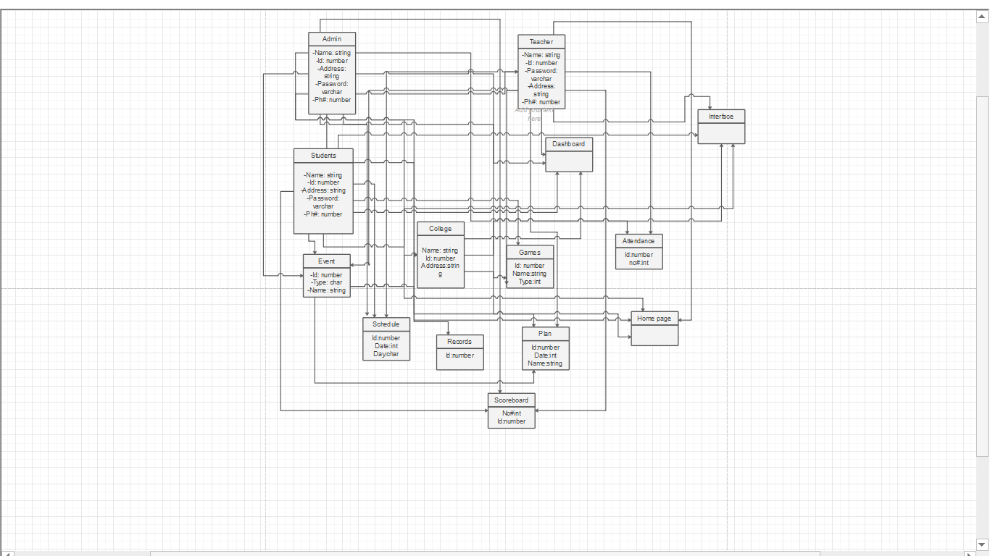

4.3. System Sequence Diagram
4.3.1 Login
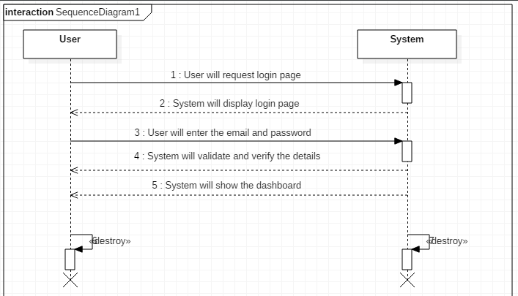

4.3.2 Logout
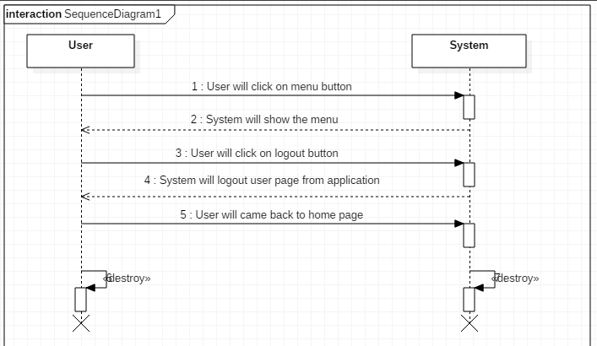
4.3.3 Add Participants
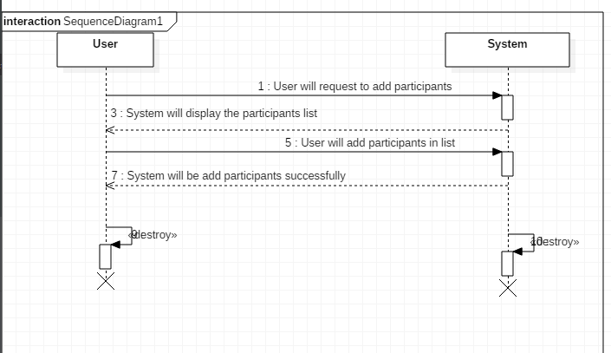

4.3.4 Add Student Detail
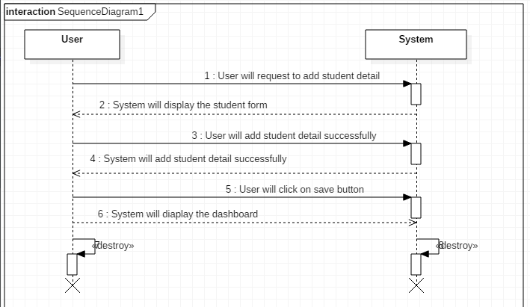
4.3.5 Add Teacher Detail
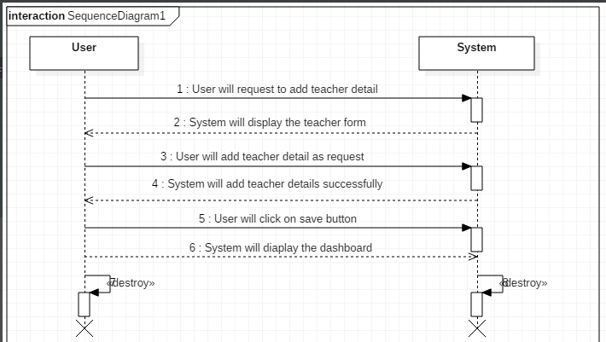

4.3.6 Attendance Page
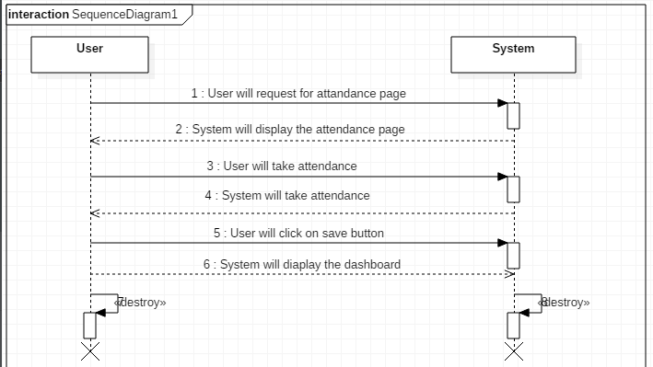
4.3.7 Change Activates
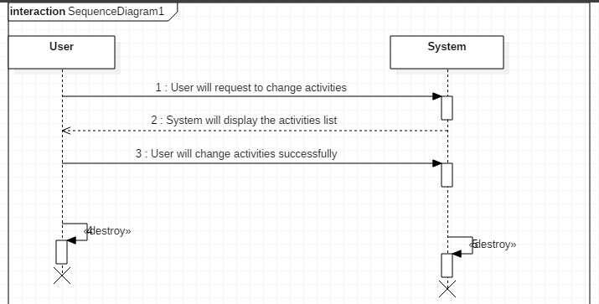
4.3.8 Change Password
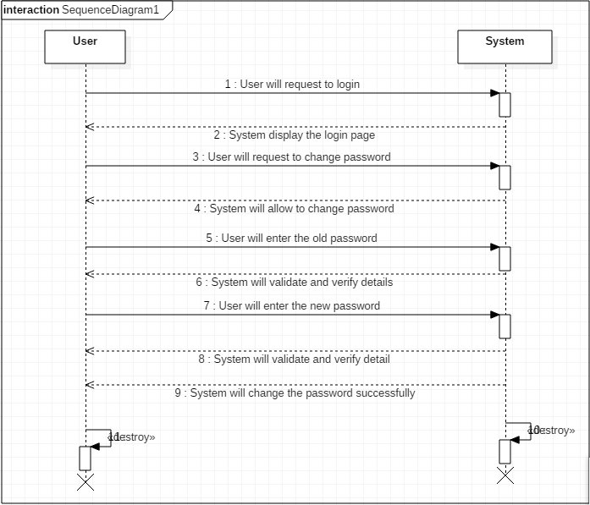
4.3.9 Create Event
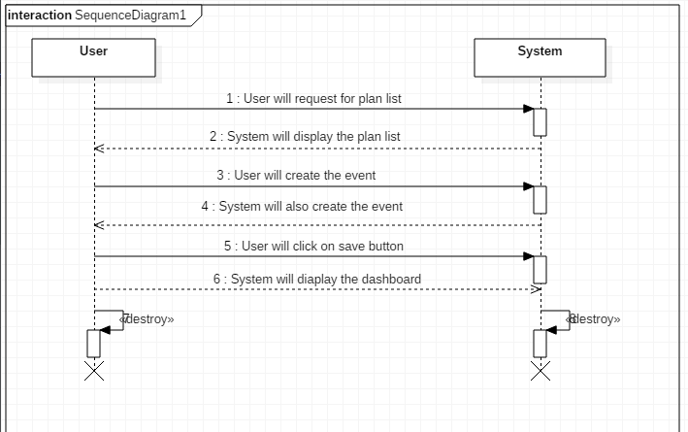
4.3.10 View Game
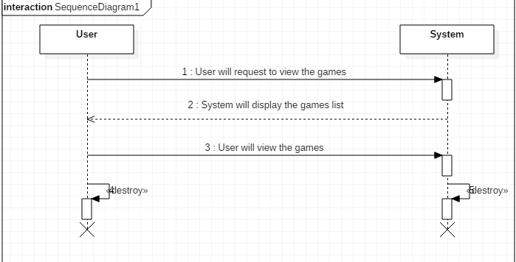

4.4. Sequence Diagram
4.4.1 Add Student Detail
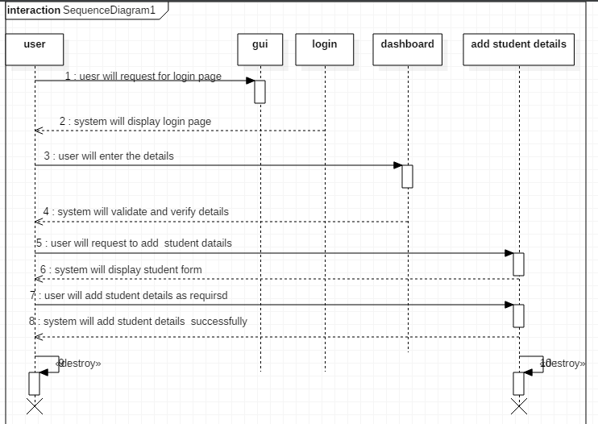
4.4.2 Add Teacher Detail
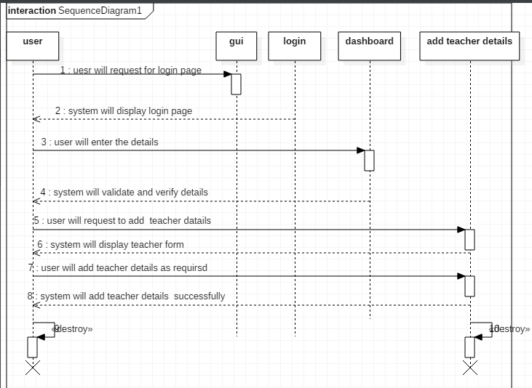

4.4.3 Change Password
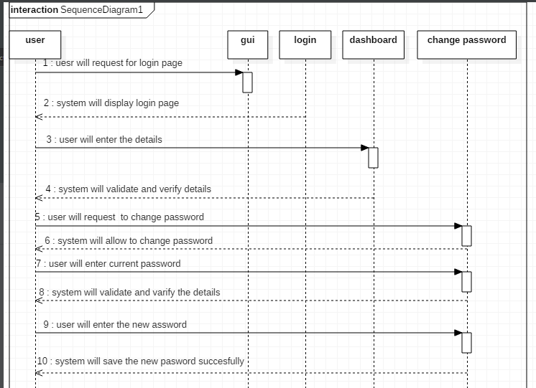
4.4.4 Change Activity
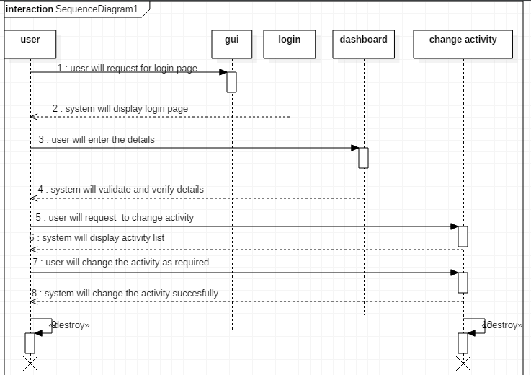

4.4.5 Create Sports Event
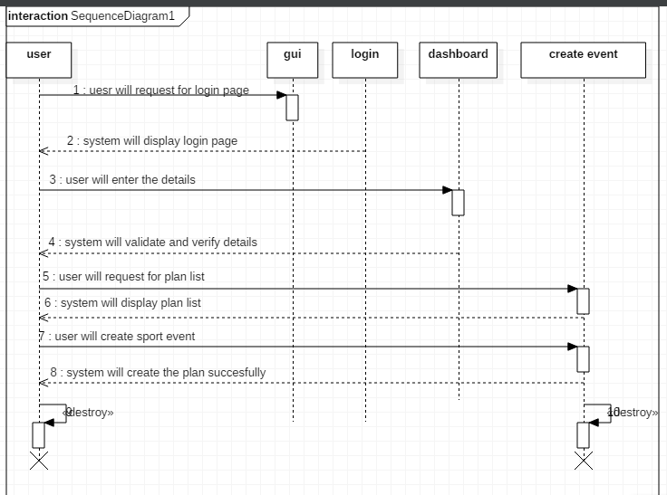
4.4.6 Login
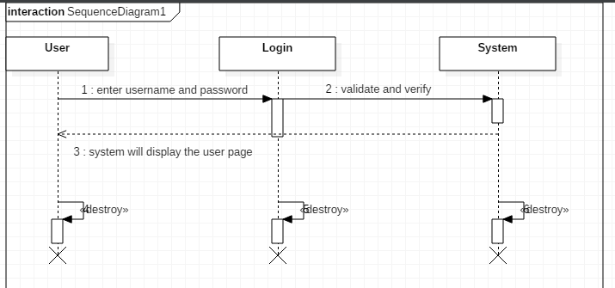

4.4.7 Logout
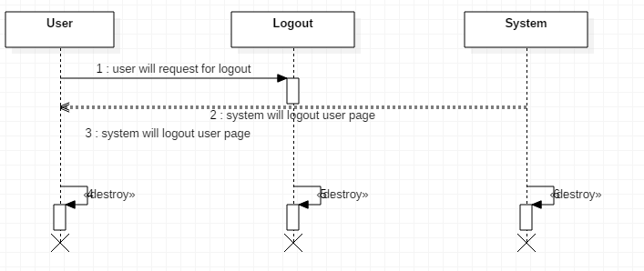
4.4.8 Take Attendance
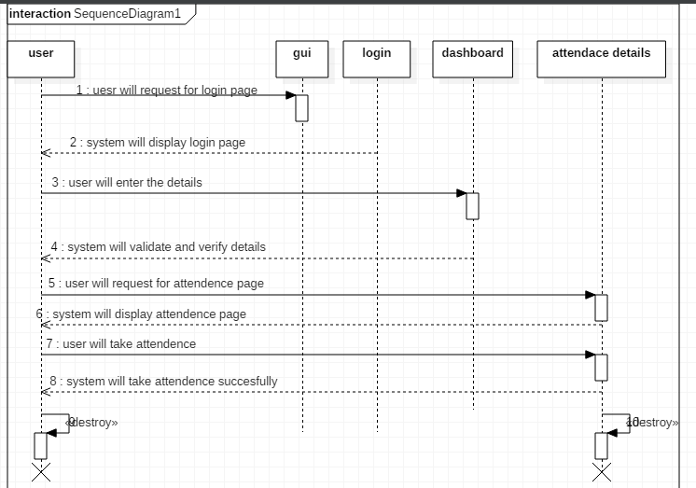

4.4.9 View Game
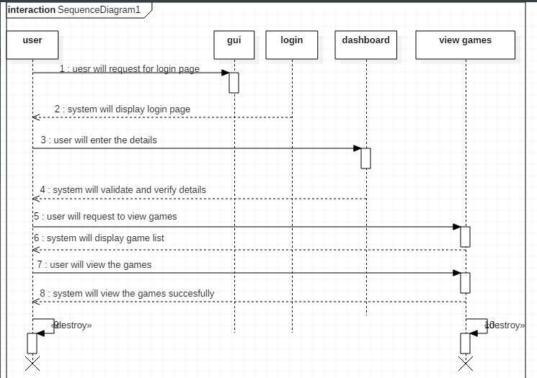

4.5. Collaboration Diagram
4.5.1 Login
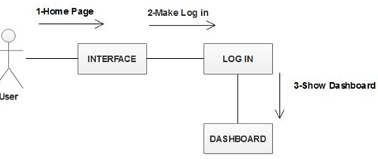

4.5.2 Registration
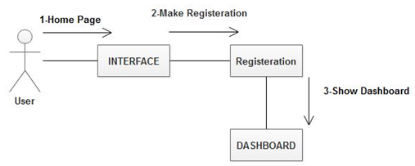

4.5.3 Logout
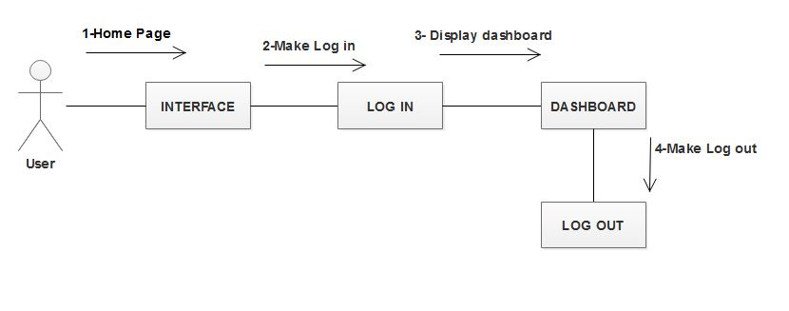
4.5.4 Response
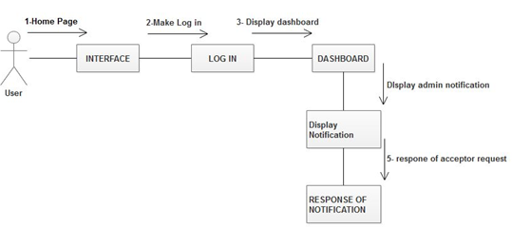

4.6. Design Class Diagram
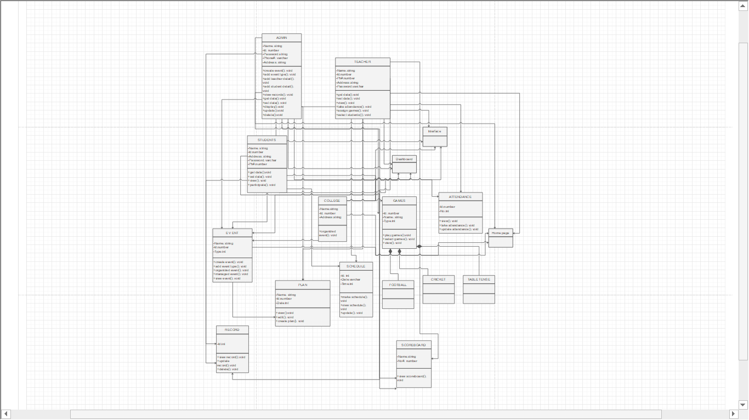

4.7. State chart diagram
4.7.1 Add participants
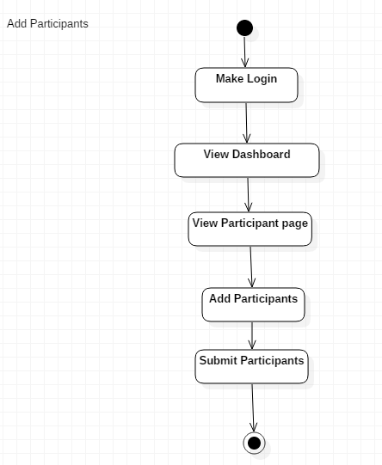
4.7.2 Add Student Detail
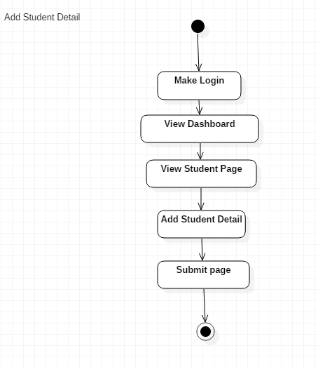

4.7.3 Add Teacher Detail
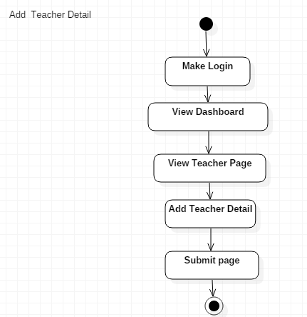
4.7.4 Change Activity
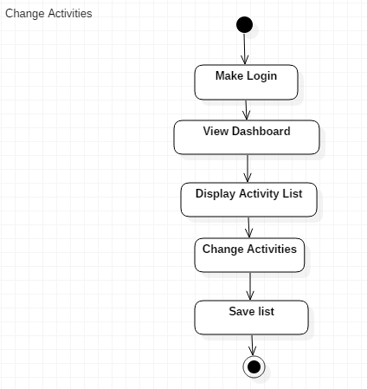
4.7.5 Change Password
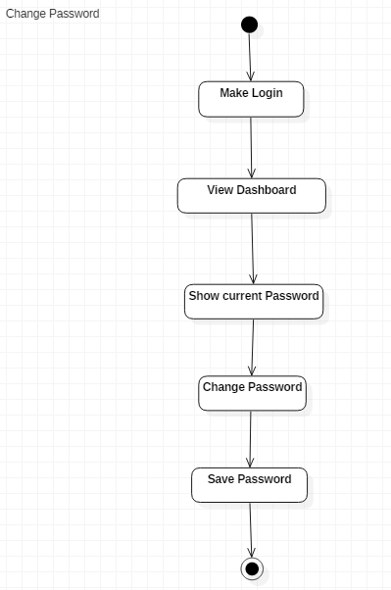

4.9. Data Model
DM:1.1 |  |  | RIGESTER
Name: ADMIN
Sr.No | Attribute | Data-type | Size | Description | Constraints
1 | First Name | Varchar | 20 | Enter the first name | NOT NULL
2 | Last Name | Varchar | 50 | Enter the last name | NOT NULL
3 | Email | Varchar | 20 | E-mail address of the Member. | Must include @ in Email.
4 | Password | Varchar | 50 | Enter the password | NOT NULL

DM:1.2 |  |  | USER REGISTER
Name: Teacher
Sr.No | Attribute | Data-type | Size |  | Description | Constraints
1 | Name | Varchar |  | 30 | Enter the Fixed Name | NOT NULL
2 | Mobile | Varchar | 20 |  | Enter the Mobile Number | NOT NULL
3 | Education | Varchar | 50 |  | Enter Education of teacher | NOT NULL

DM:1.3 |  |  | APPOINT
Name:Student
Sr.No | Attribute | Data-type | Size | Description | Constraints
1 | ID | Int | 30 | Enter the Id | NOT NULL
2 | Name | Varchar | 20 | Enter The Student Name | NOT NULL
3 | Cell Number | Int | 20 | Enter the cell number | NOT NULL
4 | Address | Varchar | 50 | Enter The Address | NOT NULL

Chapter 5: 2nd & 3rd Deliverable For structured Approach

5.1. Introduction:
Analysis & Design Model for structured approach must contain following artifacts:

- Entity Relationship Diagram
- Data Flow Diagram (Functional Model)
- State Transition Diagram (Behavioral Model)
- Architecture Design
- Component Level Design

5.2. Entity Relationship Diagram:
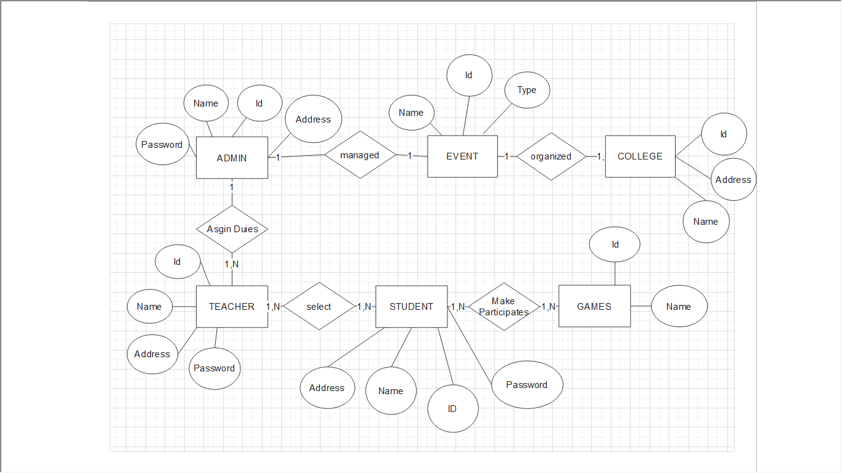

5.3. Data flow diagram (Functional Model)
Level 1:
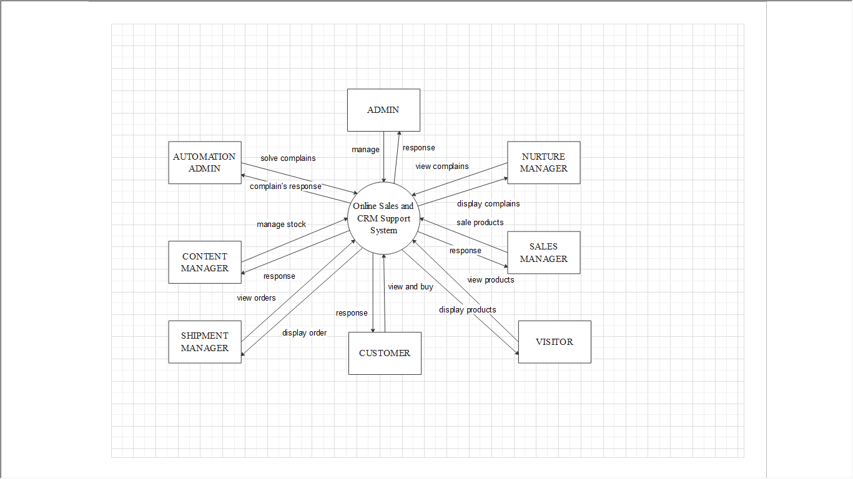

Level 2:
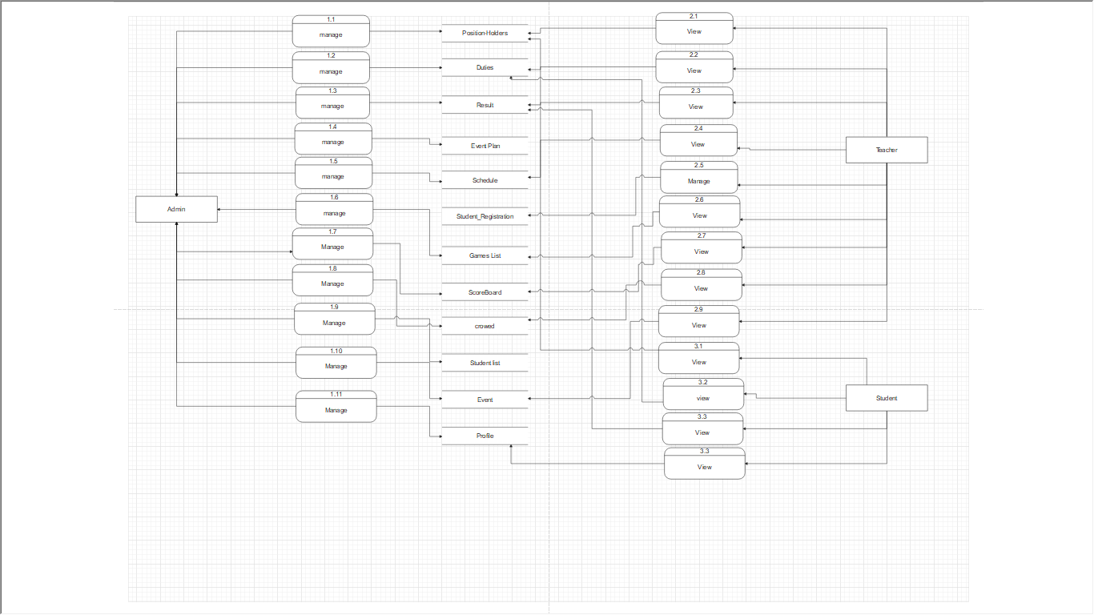

5.4. State Transition Diagram
4.7.1 Add participants
4.7.2 Add Student Detail

4.7.3 Add Teacher Detail
4.7.4 Change Activity

4.7.5 Change Password

5.5. Architectural design

5.6. Component Level Design
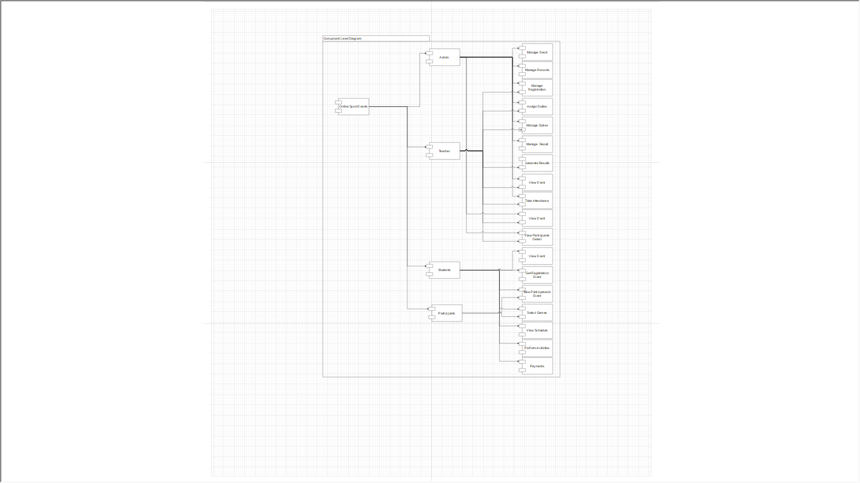

STUDY ON DIGITAL SUBSCRIBER LINE

Session : BSIT Fall 2016-2020

Project Advisor: Muhammad Bilal

Submitted By

Sadia Jamshid | 16BSIT20323
Arslan Hashmi | 16BSIT20333
Umar Raiz | 16BSIT20332

Department of Computer Science & Information Technology
University of Sargodha

